|  |
| --- |
| Lander University CIS 499 |
| Scope Statement |
| Pedigree Builder |
|  |
| **Darius Carrier, Bryan Fleming, Cody McCarter, Andrew Phillips** |
| **1/24/2014** |

|  |
| --- |
|  |

**Project**: Pedigree Builder (PeB)

**Project Team Members**: Darius Carrier, Bryan Fleming, Cody McCarter, Andrew Phillips

**Justification**: In Genetic Centers various diseases and their lineages are analyzed through pedigree charts. Many times these charts are required to be hand drawn making the process time-consuming and error-prone. Due to this fact less time is being taken on analyzing the charts and more on drawing the charts themselves. This is the exact case as it relates to the Greenwood Genetics Center. The geneticists need an efficient and effective program that can and will generate a pedigree chart from a given set of data. This will make the analysis of pedigrees a quicker and easier process.

**Problem Characteristics & Requirements**:

**Functional**

1. Open data file in a specified text format
2. Save pedigree tree in the specified text format
3. Create new pedigree tree with 2 initial generations
4. Draw pedigree tree
   1. Use data to draw the attributes of pedigree entities, including their gender shapes, familial relationships, and the status of life and phenotype
   2. Label entities with unique ID's and allele's
5. Edit existing pedigree trees
   1. Change genders
   2. Change statuses
      1. Phenotype
      2. Alive/Deceased
      3. X-link Affected
   3. Add pedigree entity
   4. Delete pedigree entity
6. Display and modify multiple mutations
7. Export pedigree tree as an image
8. Validate data and alert user to any errors

**Non-Functional**

1. Accessibility: standalone program, platform independent
2. GUI: intuitive interface

## Project Feasibility: The group has appropriate technical skills to complete this project in a timely manner. We will need to reacquaint ourselves with drawing functions and file processing, but this should not delay completion.

**Beneficiaries**: The primary benefactor is the Greenwood Genetic Center. That being said, this program could potentially aid any geneticist that frequently uses or creates pedigree diagrams. This program could become a staple of pedigree research.

**Project Deliverables**:

1. Project documentation
   1. Analysis and design diagrams and documents
   2. User manual
2. Pedigree Builder executable and source code
3. Installation
4. User training

**Project Milestones**:

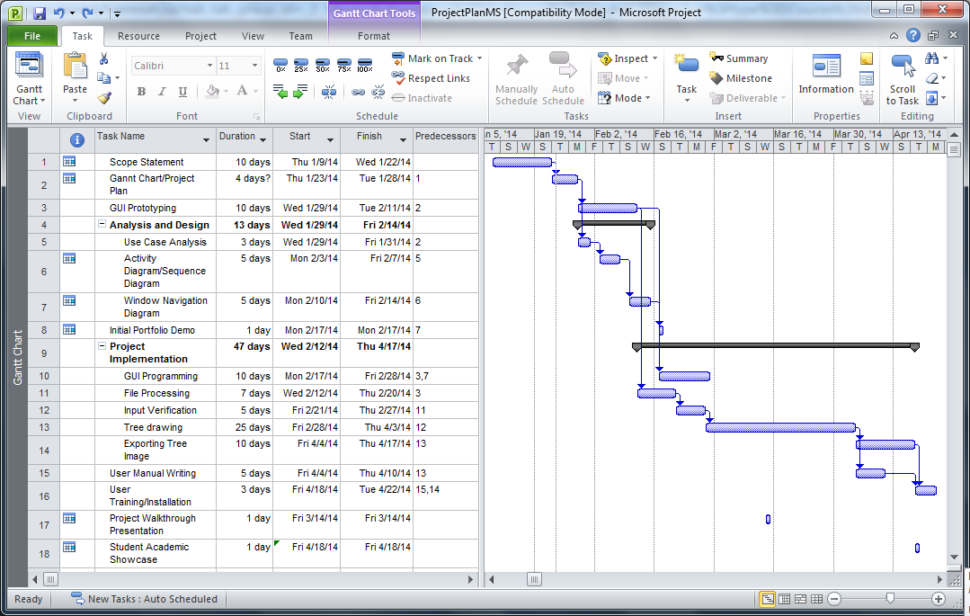

**Success Criteria**: Pedigree Builder is completed with little to no bugs, capable of meeting all functional and nonfunctional requirements. Client receives deliverables as scheduled and is satisfied.

**Team Limitations**:

1. Work
2. Other classes
3. Sport schedules
4. Unforeseen life occurrences

**Disclaimer**: This scope statement may change at any time at the discretion of our supervisors.